**Hash set with custom class-**

**Link hash set example-**



**Add two linked hash sets-**



**Add two linked hash set example two-**



**Iterate over linked hash set-**

Same as hash set.

**Convert from list interface to linked hash set-**

**Conversion from list interface to linked hash set-**

**Convert from linked hash set to list interface-**



**Conversion from linked hash set to list interface-**

**Clear method in link hash set-**

Same as hash set.

**Remove method in link hash set-**

Same as hash set.

**Tree set-**



**Iterate over tree set –**

Same working as others.

**Clear method in tree set-**

Same working as others.

**Add two tree sets-**

**Add two tree sets-**

**Conversion from list to tree set-**



**Conversion from list to tree set-**



**Conversion from tree set to list interface-**

**conversion from tree set to list interface-**



**Link hash set with custom class-**



**Tree set with custom class-**



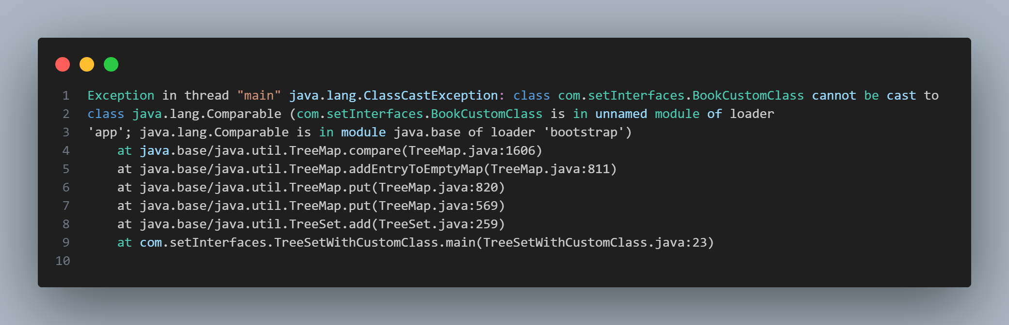

To solve this, we need to use comparable method which is abstract in nature:

**Tree set with custom class-**



